Contestant Number: ____________________
Time: ___________________
Rank: _______________



FUNDAMENTALS OF
WEB DESIGN
(405)

NATIONAL 2021

Production:
Multiple Choice (20 @ 10 points each) __________ (100 points)
Application __________ (355 points)

TOTAL POINTS __________ (455 points)

Test Time: 60 minutes

GENERAL GUIDELINES:
Failure to adhere to any of the following rules will result in disqualification:
- Contestant must hand in this test booklet and all printouts if any. Failure to do so will result in disqualification.
- No equipment, supplies, or materials other than those specified for this event are allowed in the testing area. No previous BPA tests and/or sample tests (handwritten, photocopied, or keyed) are allowed in the testing area.
- Electronic devices will be monitored according to ACT standards.

MULTIPLE CHOICE
Identify the letter of the choice that best completes the statement or answers the question.

- What is the function of this line of code?
a:hover {background-color: yellow;}
  - Background color changes to yellow when mouse is over object
  - Text color changes to yellow when mouse is over object
  - Background color changes to yellow on mouse click
  - Text color changes if color originally yellow

- Which tag is used to add scripting to a webpage?
  - <script>
  - <js>
  - <style>
  - <javascript>

- What is the correct tag use when creating checkboxes in a form using HTML?
  - <tag= “checkbox”>
  - <form type=”checkbox”>
  - <style type=”checkbox”>
  - <input type=”checkbox”>

- When you click on the “submit” button on a webform, what happens?
  - The content of the form is stored on the desktop
  - The content of the form is exported to a spreadsheet
  - The content of the form is overwritten
  - The content of the form is sent to the server

- When creating a form that will be interacting with a server, you want to make sure that the data is sent in the most secure way. Which method will you use?
  - Get Method
  - Secure Method
  - Post Method
  - Encrypt Method

- When creating a dropdown menu, which tag would you use?
  - <select>
  - <dropdown>
  - <option>
  - <input>

- Which of the following languages is NOT a popular language for writing server-based programs?
  - ASP
  - Python
  - PHP
  - C#

- When gathering information on a form, you want to allow the user to have the ability to select multiple answers per question. Which type of input would you use?
  - checkbox
  - radio
  - dropdown
  - select

- Which is the correct Html code for creating a form on the website “testsite.com”
  - <form “action=http://www.testsite.com” “method=”post”>
  - <form post=“http://www.testsite.com” method=”action”>
  - <form action=“http://www.testsite.com” method=”post”>
  - <form “action=“http://www.testiste.com method=post”>

- Which type of CSS takes highest precedence?
  - inline
  - embedded
  - external
  - internal

- As you review a website you developed, you notice that it is not usable by individuals with hearing problems. What federal legislation addresses the issue?
  - Audiology for Disable American Act
  - Americans with Limitations Act
  - Audiology Correction Act
  - Americans with Disabilities act
- To display listed items horizontally with no bullets, which two CSS properties must be set?
  - display: inline; list-style-type: none;
  - display: block; list-style-type: none;
  - display: inherit; list-style-type: disc;
  - display: none; list-style-type: inherit;

- How many bits are represented in IPv6 address 2001:adb8:0000:0000:0000:ff00:0043:8329?
  - 24 bits
  - 64 bits
  - 96 bits
  - 128 bits

- Which is not an acceptable audio format in HTML?
  - OGG
  - MPG
  - WAV
  - AAC

- You have just created a div class called “cat”, how do you target that specific div tag in your CSS?
  - #cat
  - cat
  - *cat
  - .cat

- Which language is considered a Server-Side programming?
  - HTML
  - CSS
  - JavaScript
  - None of the above

- To position an HTML element outside the normal flow of the browser's box model using CSS, use…
  - Static positioning
  - Absolute Positioning
  - Relative Positioning
  - Floats

- What is a benefit of using CSS?
  - Allows secure web browsing
  - Allows anonymous web browsing
  - Provides multiple web page formatting
  - Provides access to secure website

- Which language is Javascript?
  - <document.getelement>
  - {document-get-element;}
  - <document.get.element>
  - {document.getelement;}

- To apply the styles to every element nested within the body element, the style rule uses a(n) _________ selector.
  - Dash
  - Ampersand
  - Asterisk
  - Quote

Applications

You have been asked to create a website for a small company called “Russo’s Pizzeria”. You are going to create a three-page website for the company; first page just giving information about the company, the second page organized as a menu, and the third page to order the pizza. In this application, you will be working on the first page of the website - an informative page.

During this exercise, you are only allowed to use Notepad. The use of any other type of text editor such as Notepad++ or for web development tools such as Dreamweaver or Expression Web will result in immediate disqualification from this event.

A screen capture of the expected end result is included for your inspection and to be used as a guide for completing this exercise.

When complete, print all code generated for this exercise (HTML and Style Sheet). Also print a screen capture of your finished work as it appears in the web browser so that it may be used for grading purposes.

Submit all printed pages, along with your copy of this test, and your answer form to your proctor.

Your task is to regenerate the web page shown in the screen capture provided in this packet, using HTML 5, CSS, and the parameters specified below.

- Overall Specifications
  - The document must be valid HTML 5
  - The documents must be styled with an external cascading style sheet
    - ALL styles must be done with the style sheet. Using tags or style attributes within tags is PROHIBITED
  - The document must not use tables for any sort of layout or positioning.

- General Pages Specifications
  - Title should have Your constant number - Fundamentals of Web Design
  - Create a CSS file, stylesheets.css, underneath the previous text create a comment in the CSS that says the following “Form Styles”.
  - Set the form to the following properties:
    - Set the display to webkit-flex
    - Set the second display to flex
    - Give the webkit-flex-flow a property of row wrap
    - Give the flex-flow a property of row wrap
  - Give the fieldset the following properties:
    - Set the background color: rgb(234,189,142)
    - Set the webkit-flex to 1 1 300 pixels
    - Set the flex to 1 1 300 pixels
    - Set the margin to 10 pixels
  - Give the div tag the following properties:
    - Set the margin to 5 pixels
    - Set the width to 100%
  - Give the legend the following properties:
    - Set the font color to rgb(255, 200, 200)
    - Set the background color to rgb(179,20,25)
  - Give the label the following style properties:
    - Have the content displayed inline block
    - Set the width to 120 pixels
  - Create two fieldset, one for the ID pickupInfo label and the other for the ID deliveryInfoLabel
    - Set the bottom margin to 10 pixels
    - Set the width to 100%
  - Style the body to the following properties:
    - Background color is rgb (128, 0, 0)
    - Text Color #000000
    - The default font for page body needs to be “Times New Roman” with a fall back on “times” and another fall back on “serif”
  - Create a container using an ID that will hold all the information on the page. Use the following properties for the style on the page:
    - background color: #FFFFFF
    - width: 80%
    - Margins: top and bottom to 0 pixels and left and right to auto
    - padding: 25 pixels
  - Images must have the following style properties
    - Set the display to a block
    - Set the width of the image to 40 percent
    - Margins: top and bottom to 0 pixels and left and right to auto
  - Use a navigation tag to apply properties to the hyperlinks for the web page:
    - text align set to center
  - Use the pseudo tags to add animation to the links. Use the following properties:
    - Set the default link to Black using the correct pseudo tag
    - Set hover effect of the link:
      - Set the font color to white
      - Set the background color red

- Page Content
  - Between the opening and closing body tags, insert a div tag with the id attribute for the container style. Note, all following HTML elements will be nested inside of this “container” div element.
  - Place the Russo’s Pizzeria Logo and make sure that it is centered
    - Give the alternate text “Russo Pizzeria logo”
  - Create a navigation bar - Center (Make sure that the home Link links to the index and the menu file given to you)
    - Home | (Use the file name ‘index.html’)
    - Menu | (Use the file name ‘menu.html’)
    - Order (Use the file name ‘order.html’)
  - Create a horizontal Rule after the navigation
  - Create a semantic tag, Section to place all the form information for the customer.
  - CUSTOMER INFORMATION - h2
  - Create a paragraph and type the following text:
Thank you for using our online ordering form for quick and easy orders. Please enter your name and phone number and whether you want to place an order for delivery or pickup. Note that required values are marked by an asterisk (*). If you want to place your order over the phone, call us at (614) 555-1234.
Make the telephone a clickable link.
  - Set up the form with an action and a post:
    - Have the form action set to the value “https://www.example.com/russopizzas/customers”
    - Set the method to post
  - Use div tags to organize the content of the form.
    - Create a div tag, create a label with the for and set the value to “nameBox” after the label tag, type the text “Name*” Close the label tag
    - Create a text input for the customers first name with the following:
      - Set the name to “custName”
      - Set the id to “namebox”
      - Set the type to “text”
      - Set the place holder to read the following “First and Last name”
      - Make the textbox required
  - Close this div tag
  - Use div tags to organize the content of the form.
    - Create a div tag, create a label with the for and set the value to “phoneBox” after the label tag, type the text “Phone*” Close the label tag
    - Create a text input for the customers first name with the following:
      - Set the name to “custPhone”
      - Set the id to “phonebox”
      - Set the type to “tel”
      - Set the place holder to read the following “(nnn) nnn-nnnn”
      - Make the textbox required
      - Create a pattern for the telephone number stating that the phone number should be 10 digits long and separated in groups of 3 3 4
  - Close this div tag
  - Use div tags to organize the content of the form.
    - Create a radio button for delivery, use the following values for the radio button
      - Set the name to “orderType”
      - Set the id to “delivery”
      - Have the button pre-selected
      - Create a label with the name “delivery”
      - Have the text say “Delivery”
    - Create a radio button for pickup, use the following values for the radio button
      - Set the name to “orderType”
      - Set the id to “pickup”
      - Create a label with the name “pickup”
      - Have the text of the label say “Pickup”
  - Close this div tag
  - Create a fieldset for the delivery info with the id “deliverInfo”
    - within the fieldset, create a legend with the text “Delivery Options”
    - Within the fieldset, create a text area with the following values:
      - Set the text area name to “delAddress”
      - Set the id to “addressBox”
      - Set the placeholder to “Enter Delivery address”
    - Create a div tag within the field set,
      - within the div tag, create a label for “delBox” and have the text read “delivery Time (Leave blank for earliest delivery)
      - Set the input to the following:
        - Set the name to “delTime”
        - Set the id to “delBox”
        - Set the type “time”
      - Close the div and fieldset
  - Create a fieldset for the delivery info with the id “pickupInfo”
    - within the fieldset, create a legend with the text “Pickup Options”
    - within the fieldset tag, create a label for “pickupBox” and have the text read “delivery Time (Leave blank for earliest pickup)
      - Set the input to the following:
        - Set the name to “pickupTime”
        - Set the id to “pickupBox”
        - Set the type “time”
      - Close the fieldset
    - Create a new div tag for the submit button
      - Set the value to “Begin Building your order”
  - Create a Horizontal Rule after the Today’s Paragraph
  - Create a new paragraph
    - Use the Copyright symbol code
    - 2019 Russo’s Pizzeria. All rights reserved.

When finished creating the website, print the code and the screen capture of the browser page.
Turn in all printouts and your testing instructions to your proctor.

Sample:

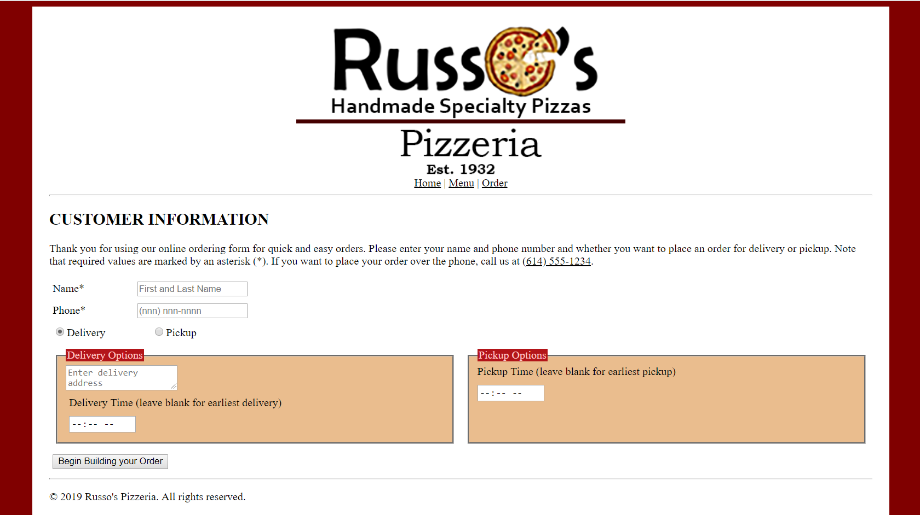
APPLICATION RUBRIC

HTML | Point Value | Score
Correct DOCTYPE declaration | 5
Set the HTML document to English | 5
<head> tag properly placed and used | 5
<title> tag includes contestants BPA membership number | 10
<link> tag reference to a CSS stylesheet | 10
Use comment tags to help organize the information | 10
<body> tag has no properties | 5
Place Russo’s Logo image “russoLogo.png” and have the image centered with the correct alternate text | 5
<nav> tag and create a navigation bar using the correct file names | 10
<hr> used under the navigation menu and the after the final paragraph after the Today paragraph | 10
<h2> tags have the correct heading titles - all in caps | 20
Have all the text have no mistakes or misspellings - 5 points taken off for misspellings | 30
Use the section tag to organize the data for the form | 5
Use the correct tags to make a functioning form. Use legends, labels, and input types. | 20
Create a hyperlink for the telephone number to make it a clickable link | 5
Create a pattern using the following format  ^\d{10}$|^(\(\d{3}\)\s*)?\d{3}[\s-]?\d{4}$ | 20
Create a submit button | 5
HTML TOTAL | 180

CSS | Point Value | Score
Style Sheet is external: (Can be called anything) | 10
Create a CSS comment for Form Styles | 5
form {display: -webkit-flex | 5
form {display: flex | 5
form {-webkit-flex-flow: row wrap | 5
form {flex-flow: row wrap | 5
fieldset { background-color: rgb(234,189,142) | 5
fieldset {-webkit-flex: 1 1 300px | 5
fieldset {flex: 1 1 300px | 5
fieldset {margin: 10px | 5
div {margin: 5px | 5
div {width: 100% | 5
legend {color: rgb(255, 200, 200) | 5
legend {background-color: rgb(179,20,25) | 5
label {display: inline-block | 5
label {width: 120px | 5
fieldset#pickupInfo label, fieldset#deliveryInfo label {margin-bottom: 10px | 10
fieldset#pickupInfo label, fieldset#deliveryInfo label {width: 100% | 10
body { background-color: rgb (128, 0, 0) | 5
body { color: #0000000 | 5
body { font-family: ‘Times new Roman’, Times, Sans-Serif | 5
#container { background-color: #FFFFFF | 5
#container { width: 80% | 5
#container { margin: 0px auto | 5
#container { padding: 25 px | 5
img { display: block | 5
img { width: 40% | 5
img { margin: 0 auto | 5
nav { text-align: center | 5
a:link { color: black | 5
a:hover { color: white | 5
a:hover { background-color: red | 5
CSS TOTAL | 175
FORMATTING | Point value | Score
Deduct 5 points for each discrepancy, up to 15 points | 15
Application Total | 355
Objective Total (from page 2)
EVENT TOTAL

